Upcoming Webinar program to disseminate our COST Action CA18213

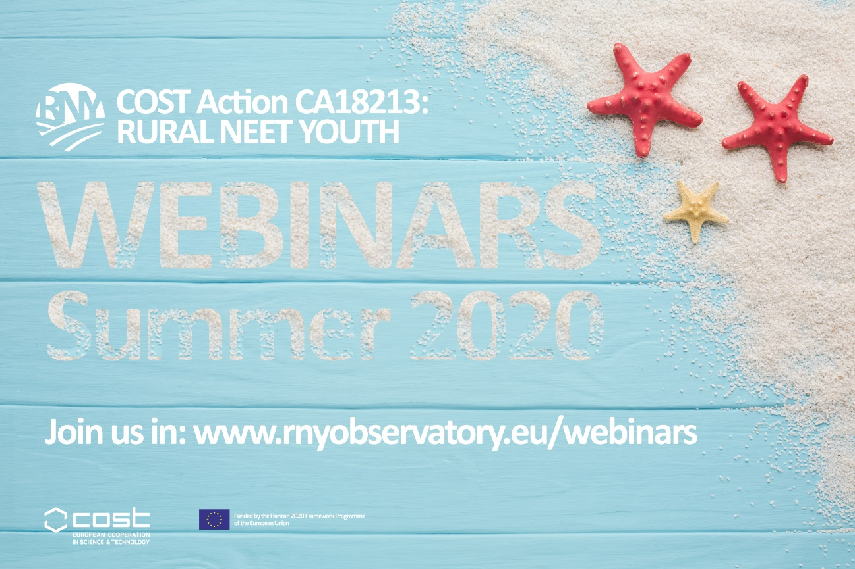

Rural NEET Youth Network (RNYN) is a four-year COST Action to be conducted between October of 2019 October of 2023. Its paramount aim is to develop a model of comprehension for rural NEETs’ risk and protective factors underlying social exclusion, based on the bioecological model. The Action general aim is supported by three specific goals: to build up future research capacity around the topic, especially in Eastern and Southern countries most affected by higher proportions of rural NEETs; to establish an online observatory of rural NEETs that will serve as a synthesizer and clearing house for research data, methodological tools and best-practices concerning rural NEETs; and to foster knowledge use by policy makers and practitioners at local, regional, national and/or international levels.

The Action currently gathers more than 80 representatives from 31 different countries. We have just launched our official website: https://www.rnyobservatory.eu/

This Webinar program steered by RNYN Core Group to be conducted in June and July 2020, involving web-based activities, presentations and discussions to engage the Action members, but also national and international stakeholders. RNYN webinar call 2020 includes 3 formats:
National stakeholders involvement webinars that are aimed at stakeholders at the national level, whether they are decision-makers, top or intermediate managers of public services or NGO’s and/or professionals; Online meeting point that is a series of webinars organized and
delivered by CA 18213 members and other scholars and professionals and will be attended by CA 18213 members, fellow colleagues, scholars and stakeholders outside the Action; and Premium lectures & discussions, that are webinars organized by the Core Group and delivered by an invited keynote speaker or groups of speakers, whether they are scholars or representatives of international stakeholders.

More about this webinars and scheduled events in https://www.rnyobservatory.eu/webinars

CALENDAR:

- 24 June 2020 – 15:00h CET | PREMIUM SESSION "Rurality: Meaning and defining dimensions" - Aleksandar Lukic (University of Zagreb, CRO)

- 29 June 2020 – 15:00h CET | PREMIUM SESSION "NEETs: profiles and typologies" - Massimiliano Mascherini (Head of Social Affairs Unit, Eurofound)

- 2 July 2020 – 15:00h CET | ONLINE MEETING POINT "Good practices to reconnect young rural NEETs: public policies versus local responses" - Maria Manuel Vieira (ICS) | Tatiana Ferreira (ICS) | Lia Pappámikail (Polytechnic Institute of Santarém)

- 6 July 2020 – 15:00h CET | National stakeholders involvement webinars "NEET youths profile in The Azores: What do we know so far?" - Francisco Simões (CIS; ISCTE-IUL)

- 9 July 2020 – 15:00h CET | PREMIUM SESSION "Youth participation in labour markets: Insights from 11 European countries" - Jale Tosun (Heidelberg University, GER)

- 13 July 2020 – 15:00h CET | PREMIUM SESSION "Estonian Youth Guarantee and Its Values" - Heidi Paabort, Kerli Kõiv (Eesti Avatud Noortekeskuste Ühendus)

- 16 July 2020 – 15:00h CET | PREMIUM SESSION "Being NEET in Europe Before and After the Economic Crisis: An Analysis of the Micro and Macro Determinants" - Antonella Rocca (University of Naples, IT)

- 20 July 2020 – 15:00h CET | Online meeting point "The perceived prestige of agricultural occupations among youth" - Miroslava Bavorova (Czech University of Life Sciences Prague)

- 31- July 2020 – 15:00h CET | ONLINE MEETING POINT "Becoming a young farmer in the digital age: case studies on European islands" - Ilkay Unay-Gailhard (Leibniz Institute of Agricultural Development in Transition Economies (IAMO))
Contacts:
- Science Communication Manager:
Mariano Soler Porta (Universidad de Málaga) Spain - mariano.soler@uma.es
- Action Chair
Francisco Simões (CIS-IUL - Centro de Investigação e de Intervenção Social) Portugal -Francisco.Simoes@iscte-iul.pt

IMAGES AND PHOTOS:
