PERSONALised prediction, prevention and treatment of chronic societal diseases from Microbiome-ENDocannabinoidome axis profilING (PERSONAL-MENDING)
The human microbiome, and in particular the gut microbiome, has been recently suggested to play a fundamental role in several peripheral and central disorders characterised by enhanced systemic inflammation, including inflammatory bowel diseases, obesity and type 2 diabetes, neuroinflammatory disorders, and cancer. However, most of the studies that have led to suggest such role are of a correlative nature, and still very little is known on how the biomolecular aspects of host-microbe cross-talk contribute to the negative effect on health of intestinal dysbiosis. The endocannabinoid signalling system, and its extended version, i.e. the endocannabinoidome, encompassing hundreds of endocannabinoid-related lipid mediators, their metabolic enzymes and molecular targets, is widely recognised to be involved in all aspects of mammalian physiology and pathology, has already served for the development of new therapies and was recently shown to play an important role in dysbiosis-induced metabolic malfunctioning, leading to the metabolic syndrome. The purpose of this consortium is to take advantage of the wealth of correlative human data on alterations of gut microbiota, on the one hand, and the endocannabinoidome, on the other hand, which have been associated with disease, to design new preclinical studies aiming at modeling endocannabinoidome-mediated host-microbe communications leading or contributing to pathological states. The ultimate aim of the project is to develop new personalised therapeutic approaches based on the biomolecular profile of individual dysbiosis and its modulation/exacerbation by an altered endocannabinoidome.
The project will include European experts on the bioinformatic analysis of available microbiome metagenomics (Claesson et al., Nat Rev Gastroenterol Hepatol. 2017) and “endocannabinoidomics” (Ligresti et al, Physiol Rev 2016) data, and their correlations, in chronic societal diseases of interest, in order to hypothesize cause-effect relationships between alterations of microbial composition or the systemic (blood) endocannabinoidome, or both, and disease. Associations will also be sought among polymorphisms in endocannabinoidome genes, dysbiosis and disease. Finally, bioinformatic approaches will be used also to identify microbial metabolic pathways that could lead, also through the interaction with the ones from host cells, to endocannabinoid-like mediators, in particular fatty acid amides (Cohen et al., Nature 2017). These tasks will be facilitated by the strong support of the Canada Excellence Research Chair on the Microbiome-Endocannabinoidome Axis in Metabolic Health (CERC-MEND), at Université Laval in Qubece City, Canada, directed by the PI of the project, who also directs the Joint International Research Unit of the Biomelecular and Chemical Study of the Microbiome in Metabolic Health and Nutrition (JIRU-MicroMeNu), between the Italian C.N.R. and Université Laval. The CERC-MEND is also part of the “National Research Core - Canadian microbiome initiative 2”, that is being formed during the preparation of this project. Databases and tissue banks from pediatric patients (Max Delbrück Center for Molecular Medicine, Berlin, Germany, and Gaslini Hospital, Italy) will be also used.
The mechanistic aspects of the hypothesized cause-effect relationships between alterations of microbial composition and the systemic endocannabinoidome and disease, and the role of the host- and microbe-derived metabolites and their molecular targets, will be then investigated by European partners with worldwide recognised expertise in the endocannabinoid system, using animal models of metabolic disorders and cardiometabolic risk (CNR, Italy), neuroinflammatory disorders and malignancies (Universitad Complutense, Spain), and chronic pain (Polish Academy of Sciences, Poland, and Universita’ della Campania, Italy). Epigenetic alterations leading to endocannabinoidome/microbiome-mediated pathological states potentially translated into developmental disorders will be also investigated (University of Vienna, Austria). New selective or multi-target pharmacological tools specifically designed to manipulate the levels and action of these metabolites will be developed (University of Leiden, The Netherlands) and tested by all partners, and their efficacy and safety further investigated through the use of proteomics approaches (CNR, Italy), and genetically modified mice (CERC-MEND) and zebrafish (CNR, Italy). Finally, nutritional approaches for the prevention of diseases will also be investigated in both animal models (EU partners) and human volunteers (JIRU-MicroMeNu).
The expected outcome is the identification of a completely new generation of microbiome- and endocannabinoidome-derived genome and metabolome biomarkers and molecular targets (enzymes, receptors, etc.) to be used for the development of personalised pharmacological and nutritional strategies for the prevention and treatment of chronic societal diseases.
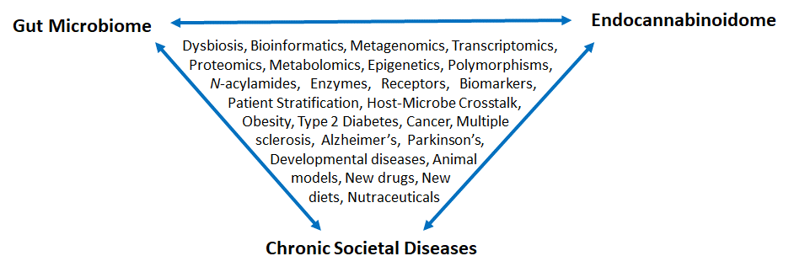
Contacts: Vincenzo Di Marzo, Istituto di Chimica Biomolecolare, CNR, Italy, and Canada Excellence Research Chair on the Microbiome/Endocannabinoidome Axid in Metabolic Health, Université Laval, Quebec City, Canada. vdimarzo@icb.cnr.it; vincenzo.dimarzo@criucpq.ulaval.ca
Paola Cormio, Istituto di Chimica Biomolecolare, CNR, Italy, pcormio@umilaval.cnr.it

Expertise requested:
Microbiology of the gut microbiota; Metagenomic analysis of the microbiota; Bioinformatics and big data management.

