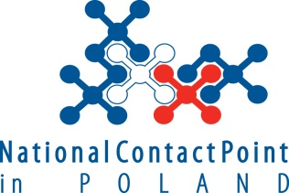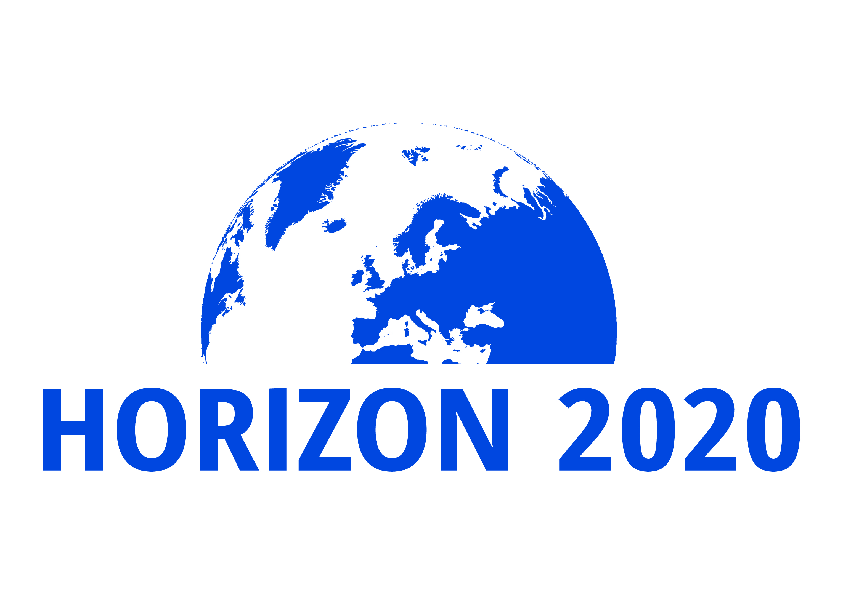

EC Communication Campaign:
Horizon 2020 Financial rules

28 November 2017, Warsaw

Venue: Dawny budynek biblioteki (Stary BUW)
Uniwersytet Warszawski
Ul. Krakowskie Przedmieście 26/28
00-927 Warszawa

Speakers: Mr David Mejuto, RTD.J1 Common Legal Support Service, European Commission
Mr Marcin Jagielski, RTD.J2 Common Audit Service, European Commission

Language: English (Translation will not be provided)

09.00 – 09.30 | Registration
09.30 – 09.40 | Welcome and introduction  Dr Zygmunt Krasiński, Dyrektor Krajowego Punktu Kontaktowego Programów Badawczych Unii Europejskiej
09.40 – 10.00 | Introduction by EC representative
10.00 – 10.15 | H2020 model Grant Agreements – Introduction  - Structure  - Forms of costs  - Budget transfers
10.15 – 10.45 | Types of staff contracts  - Employees VS other staff  - What contract under what budget category
10.45 – 11.30 | Personnel cost calculation  - Time-recording requirements  - Actual personnel cost vs unit costs  - How to calculate actual personnel costs: annual vs monthly rates  - Options for annual productive hours
11.30 – 11.50 | COFFEE BREAK
11.50 – 12.35 | Personnel cost calculation - continuation  - Time-recording requirements  - Actual personnel cost vs unit costs  - How to calculate actual personnel costs: annual vs monthly rates  Options for annual productive hours
12.35 – 13.20 | Additional remuneration  - Definition  - Basic remuneration vs additional remuneration  - Decisional tree  - Additional remuneration ceiling
13.20 – 14.20 | LUNCH
14.20 – 14.50 | Direct costs  - Identification and measurement  - Eligibility Conditions
14.50 – 15.20 | Third parties  - Types of third parties: classification and characteristics
15.20 – 15.50 | Subcontracting  - Subcontracts Vs Contracts  - Characteristics and eligibility conditions  - Conflict of interests and best value for money
15.50 – 16.05 | Synergies with other grants  - Basic principles  - Concept of "cost item"
16.05 – 16.40 | Final questions

