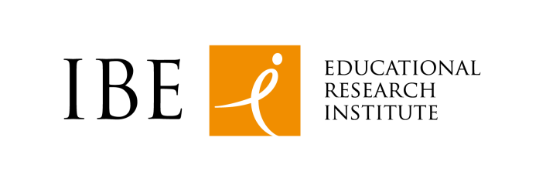
Górczewska 8 str
01-180 Warsaw, Poland
Tel. 0048 222417100
www.ibe.edu.pl

Our mission and main focus
Instytut Badan Edukacyjnych IBE (Educational Research Institute) conducts interdisciplinary research on the functioning and effectiveness of Polish education system. The Institute strives to support and raise the quality of Polish education by sharing its in-depth knowledge about the system and the learning environment. The Institute's diverse research activities, sometimes pioneering projects, focus on development of research guidelines for subject teaching,
in-depth studies of the teaching community and monitoring careers of school leavers, the most powerful proof of educational outcomes. IBE sees ICT implementation as one of the most important areas for school teaching and practice.
We are interested to take a part as a partner organization in projects H2020-ICT-2015
topic:
ICT-20-2015 Technologies for better human learning and teaching.

Our expertise and competences
IBE key research area covers i.e. assessment of the results of the new core curriculum implementation into school practice in the lifelong learning perspective. IBE research work pertains to all stages of education - from preschool and school up until the entry into the labour market and adult learning, addressing such areas as ICT competences of youth and adults, core curriculum and development of subject teaching methods; psychological and pedagogical determinants of school achievement; sociological and legal aspects of education policy; education economics.
The Institute employs over 130 researchers – sociologists, psychologists, educators, economists, political scientists and representatives of other disciplines. Some of them have been members of the following stakeholders: EC Thematic working group ICT and Education, PEGI Council (Pan European Computer and Video Game Rating System), Polish Safer Internet Committee, College Board Member Council, Polish Committee of the UNESCO Project “Information for All”, European Policy Network on School Leadership, European Association of History Educators, Evidence Informed Policy and Practice in Education in Europe.
References and key achievements
IBE cooperates with higher education institutions both in Poland and abroad, and numerous other educational institutions for the purpose of information and experience exchange.
IBE takes part in ICILS research (International Computer and Information Literacy Study).
It also participates in numerous international student and teacher assessments, which have ICT component, including: PISA (Programme for International Student Assessment), TALIS (Teaching and Learning International Survey), ESLC (European Survey on Language Competences), PIAAC (Program for the International Assessment of Adult Competencies), TIMSS (Trends in International Mathematics and Science Study), SHARE (Survey of Health, Ageing and Retirement in Europe), PIRLS (Progress in International Reading Literacy Study).
IBE was responsible for the evaluation of the government intervention aimed at improving ICT competences in Polish schools, known as the “Digital School Project”, and has done “Computer Readership Survey of Children and Youth”, as well as research on “Computer and video games in student’s lives” IBE has a broad school database that can be used during next surveys. Organizes conferences such as “Modern technologies in inclusive education”.
Participation in EU Funded Projects
At present IBE starts to participate (from 2015) in four international research projects financed by the Erasmus + and the Horizon2020 European Union programmes:
- “CoderDojo Training in ICT Programming Skills” (Erasmus +)
- Project Innovating History Education for All (Erasmus +)
- Project Designing and Testing new management skills for the development of the Waste Electrical and Electronic Equipment Recycling and Re-use System in Europe (Erasmus +)
- Social Exclusion of Youth in Europe: Cumulative Disadvantage, Coping Strategies, Effective Policies and Transfer (Horizon 2020)
So far the Institute has managed six multiannual national research projects co-financed by the European Social Fund:
- “Quality and effectiveness of education - strengthening of institutional research capabilities”,
- “Developments of terms of reference for the implementation of the National Qualification Framework and the National Qualification Register for lifelong learning”,
- “Developing the national qualifications system – preparing to implement the Integrated Qualifications Register for lifelong learning”,
- “Developing the national qualifications system – pilot implementation of the national qualifications system and its promotional campaign”,
- “Educational Value-Added method for enhancing the evaluation function of national examinations”,
- “National Survey of the Third class Primary school pupils - Nationwide Testing
of Skills of Third Graders”.

